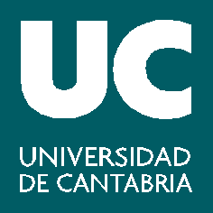

V Convocatoria de Ayudas para la Formación del PDI de la Universidad de Cantabria para impartir Docencia en Inglés -Marco de la Acción de Movilidad para Formación del Programa Erasmus+

CURSO 2018-2019

ANEXO V . Memoria explicativa

- Satisfaction with:

  - The course in general
  - The instructors
  - The facilities
  - The classes
  - The course contents
  - The accommodation
  - The extra-curricular activities

- Personal achievement:

  - Development of language skills
  - Development of academic language
  - Development of appropriate teaching methodologies

- Other comments

